Prototype & Usability Testing Report

AT1 KIT305, Joshua Crisford, 574082

## Introduction

This report presents and analyses the design principles and usability evaluation of a low-fidelity prototype for an Australian Rules Football (AFL) statistics recording application. The application is designed to provide local AFL game officials with a fast and reliable tool to track player actions and team performance in real time, while offering general users with an interface to view this data. The application enables users to record actions such as kicks, handballs, marks, tackles, goals, and behinds as they occur, providing immediate data on player contributions and team statistics throughout and after a match.

The primary target audience for this application includes match officials, specifically coaches and statisticians, working at amateur and semi-professional levels. . These users often work in time-pressured environments, with limited staffing and resources (particularly financial resources) compared to the professional league. To meet these demands the application design focuses on usability, efficiency, and minimal cognitive load. To that end, special consideration was made to include intuitive navigation, quick access to frequently used actions, and clear visibility information and actions. The design also emphasises forgiveness and failure-resistance, providing accurate data collection and an easy way to record and review AFL statistics.

While similar applications such as Champion Data software are used at the professional level, they offer complex, networked data collection that are impractical for local games due to their resource requirements. This prototype, by contrast, focuses on delivering essential features for statistical tracking while simplifying data entry. Although other mobile apps exist for different sports that prioritise streamlined interfaces and quick action recording; they often lack customisation for AFL-specific customisation needed for effective local use.

## Usability Goals and Design Principles

The design of this AFL statistics recording app was guided by established usability goals that ensure an intuitive, efficient, and reliable user experience. This section outlines how the application addresses usability goals such as learnability, efficiency, and failure resistance, while also incorporating Don Norman’s six design principles: visibility, feedback, affordance, mapping, constraints, and consistency (Norman, 2013). These usability goals are key considerations in user-centred design and ensure applications are intuitive and effective for their intended audience (Sharp, Rogers & Preece 2019). These goals are also closely aligned with established usability heuristics, which emphasise system visibility, user control, and error prevention (Nielsen, 1994). Together, these principles and heuristics informed key interface decisions that enhance the application’s usability and positive user experience.

### Usability Goals

The usability goals are especially important for meeting the needs of match officials and statisticians who often work under time constraints and high cognitive load. Each goal influenced design features to improve ease of use, efficiency, and error prevention.

#### Learnable on First Use

Consideration was given to ensuring the application is intuitive and easy to use, even for first-time users. The interface follows a straightforward and consistent layout, with clearly labelled buttons and simple navigation, removing the need for prior instruction.

* The Match Creation screen presents users with a clear, logical, step-by-step flow to enter teams before starting a match.
* Language used is kept simple and familiar to the sport, using terms like “Kick”, “Goal”, and “End Quarter” that aligns with the AFL officials’ mindset.
* *A screenshot of a phone

  AI-generated content may be incorrect.*Visual cues are included, such as placeholders in input fields and large clear headings, guiding the user through tasks.

*~ Note: Larger version of images can be found in the* [*Report Images*](Report%20Images) *folder ~*

#### Memorable on Repeat Use

Once users have used the app, they should be able to remember how to complete tasks easily on subsequent visits.

* The interface follows a consistent design language is maintained throughout the app including uniform colour schemes, button placements, and screen layouts.
* Frequently used actions, such as recording player actions, are located in the same position and accessible with a single button on the main menu, encouraging familiarity.
* A screenshot of a cell phone

  AI-generated content may be incorrect.The use of repeated structures, such as the identical layouts for Player Stats and Team Stats, require minimal learning and help users apply their knowledge across different parts of the app.

#### A screenshot of a football form AI-generated content may be incorrect.Efficient

Efficiency is crucial when recording live match events, so the design focuses on minimising the steps required to perform the frequent recording actions.

* Actions are recorded in two simple steps: selecting a player from the dropdown and selection the desired action.
* The Record Action panel consolidates both the teams into a single interface, reducing unnecessary navigation and interaction.
* Real-time match information including the current score and quarter is displayed at the top of the screen allowing immediate access to data while recording actions without having to navigate away from the live match screen.
* Feature such as leaderboards and highlight are readily accessible allowing officials to make fast comparison without slowing workflows.

#### Failure-Resistant

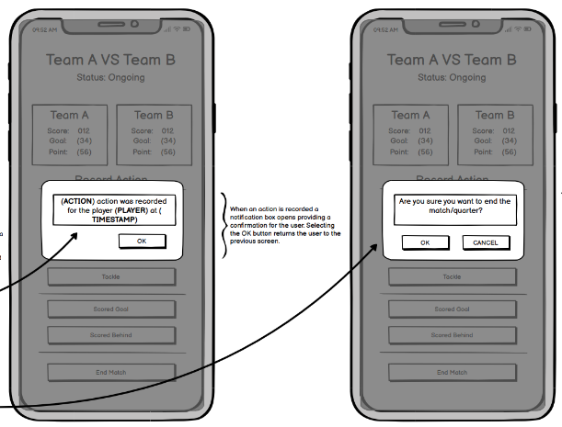The application is designed with consideration to failure-resistance to minimise user errors and ensure accurate data entry, particularly during live matches.

* Included game logic constraints prevent illogical actions. For example, a scored goal can only follow a kick, and a scored behind only after a kick or handball.
* Important actions like ending a quarter or a match prompt a confirmation from the users to avoid accidental selection.
* After recording actions, a confirmation message appears, showing the action, player involved, and timestamp. This helps users confirm and verify their entry instantly.
* Greyed-out buttons prevent users from selection unavailable action reducing mistakes.

#### Forgiving

The application is designed to help users recover from errors providing reassurance and flexibility.

* Confirmation messages appear immediately after actions are recorded allowing users the opportunity to detect mistakes.
* Critical actions like enabling a quarter or match include confirmation prompts to allowing the user to prevent making irreversible mistakes.
* In an action was incorrect users can remove or edit the entry during the live match *(this feature was not demonstrated in the prototype as it wasn’t a requirement on the assignment specification, however, ideally it would be included in real prototype).*

#### Satisfying

Thes application is designed to provide a smooth, relatively stress-free experience that provides user confidence and satisfaction.

* A clean uncluttered interface making navigation intuitive and reduces distractions.
* Scoreboards are always visible within the action recording interface, requiring fewer actions from the user.
* Leader highlights provided for each data point in both compare teams and compare player screens, giving immediate insight to users without having to search for it.
* Game highlights accessible from both live match and match history providing a quick and accessible overview of key statistics.
* Consistent colour schemes maintain readability in various environments. Clear commonly used icons are included for automatic recognition of functionality.

*~ See next page for example image ~*

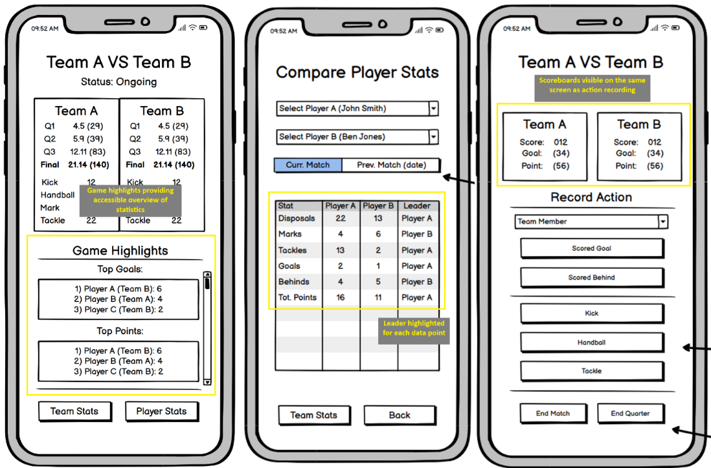

### Design Principles

Don Norman’s design principles heavily influenced the design of the AFL statistics recording application (Norman, 2013). These principles were applied to support an efficient workflow, align with user expectations, and minimise likelihood of user error.

#### Visibility

The application ensures that users can always view the current and past games status as well as important information, without the need to switch screens.

* A screenshot of a match

  AI-generated content may be incorrect.Scoreboards are permanently visible on the action recording screen ensuring users have access to critical information without switching screens.
* Quarter and match status indicators displayed on primary screens.
* Scroll indicators for games highlights make it clear when more information is available.
* Button highlighting makes it clear what information is selected.
* Dropdown fields display selected player or team names making it clear what information is selected.

#### Feedback

Clear and immediate feedback is essential to guide users and confirm their actions have been successful.

* An ‘action recorded’ confirmation message appears immediately after recording an event, assuring users that their input has been recorded.
* Confirmation windows for ending a quarter or match prevent unintended actions
* Game highlights offer users accessible and instant feedback on key data.

#### Affordance

Design elements should suggest to the user how they are meant to be used.

* Buttons are clearly labelled to explain what they do and sized appropriately suggesting they are tappable.
* The scroll bar indicator in Game Highlights suggests to users that they can scroll to find further information.
* Navigation tabs afford switching between different data views.

#### Mapping

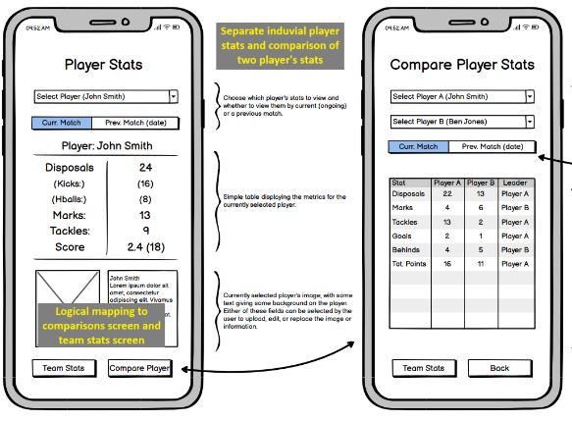The relationship between control elements and their effect must be logical and intuitive.

* The Record Action panel groups player selection and action buttons in a logical grouping and order that mirrors the workflow of a match official.
* Team-based bata and player-based data are clearly separated in screens (individual team/player stats and comparison of two teams/players) but also allow quick navigation between team and player data maintaining a logical flow without confusing the two similar but distinct data sets.
* Actions that follow game logic, e.g. a goal scored after a kick, are laid out to reflect these processes.

#### Constraints

The application should limit user action to prevent errors.

* Greyed-out buttons to prevent users from selecting actions that are not allowed.
* Confirmation prompts for ending quarter or matches, containing important actions by requiring deliberate input.
* Only valid actions are displayed within the context of the action, e.g. the user cannot start a match without selecting two teams.

#### Consistency

Application design should be consistent across the application promoting learnability and efficiency.

* Consistent colour schemes, fonts, and element styles (e.g. buttons) are applied consistently across all screens.
* Terminology is constant and uniform both across the application but also with AFL terminology to provide predictability for users.
* The layout for Team Stats and Compare Team Stats is consistent with Player Stats and Compare Player Stats to enforce familiarity between these two similar tasks and data sets.

## Usability Testing Methodology

Usability testing for the AFL statistics recording application was conducted using the Think-Aloud Protocol. The method was suitable because it allows collected for qualitative feedback regarding the users’ mental model, their decision making, and reactions to the interface. This approach is a widely used usability testing method for gathering qualitative insights into users’ cognitive processes (Ericsson and Simon, 1993, Nielsen, 1993). Testing was conducted on two occasions each with different versions of the prototype, V1 and V3.1.Updates were made between tests based on user feedback and the facilitator’s observations. Iterative prototyping and evaluation, in which user insight drive design improvements, is a fundamental principle of user-centred design (Sharp, Rogers & Preece 2019).

### Participant Recruitment

Participants included peers within the ICT Batchelor course and personal friends. Some expressed interest in sports (AFL specifically) and others in mobile applications, a couple in both. Five participants were recruited in total with two completing the testing for the final V3.1 prototype version and three in the earlier round of the V1 prototype.

#### Participant Profiles

* All participants were at least moderately familiar with mobile apps and two demonstrating a more advanced understanding. There was a varied knowledge of AFL between participants ranging from novice to casual fans.
* No professional AFL statisticians or coaches were involved which demonstrates a bias toward casual users. Therefore, the feedback may not reflect the expectations of the target audience.
* Most participants were from a similar educational background (ICT students) which will have likely limited the generalisability of the results however, participants from different backgrounds were included to limit this effect.

#### Justification

* Despite the noted limitations, the participants chosen do reflect likely users of the app at the amateur and semi-professional levels of AFL, where statisticians and coaches are often volunteers with limited or no formal training.
* Recruitment from the ICT Batchelor course was very practical considering the given time and resource constraints of the project. It allowed for quickly attainable feedback during the prototyping process.

#### Limitations

* The small sample size (five participants) limits usability insights. Ideally, a minimum of five participants per testing round (10 in total) would have been preferred to uncover a wider range of usability issues.
* This think-aloud protocol may have influenced user behaviour, as some participants appeared to act differently when attempting to verbalise thoughts during testing.

### Testing Environment

Usability tests were conducted in quiet to minimise distraction and allow participants to focus on the tasks.

* The low-fidelity prototype was given to participant on multiple sheets of A4 paper, each representing the function groups of the application (Action Recording, Live Match Viewing, Match History, Player Stats, Team Stats).
* The facilitator recorded observations using a laptop, noting participant behaviour and task completion times.
* A smartphone with a voice recording application was used to record voice commentary during the think-aloud sessions for later transcription and analysis
* All tests were conducted in person to allow the facilitator to simulate screen transitions by manually moving the prototype paper based on the participant’s actions.

### Testing Process

Each session began with an explanation of the applications purpose and what to expect during the testing process. Participants were informed that the prototype was not interaction, and the focus should be on verbalising their thoughts while completing tasks.

#### Introduction and Instructions

Participants were instructed to complete the tasks as if they were using a live interactive app and encouraged to think aloud, describe what actions they were taking, what they expected to happen, confusion felt, and the general decision-making process. They were assured that the test intended to evaluate the applications design, not their ability, and to provide honest feedback, whether negative or positive.

#### Execution

Participants were given six usability test tasks (T1-T6) one at a time. The facilitator manually swapped the paper screen to simulate the navigation between the app based on participant’s choices. Assistance or hints were not given unless explicitly requested by the participant or they became stuck for an extended period. Task completion times were recorded using a stopwatch application on the facilitator’s laptop.

#### Data Collection

* Verbal feedback was recorded using a smartphone voice recorded.
* Facilitator took written notes on points of confusion and errors, task completion, and witnessed usability issuing observed.
* Each task was marked as complete or incomplete along with the facilitator’s qualitative observations.

### Usability Test Requirements, Tasks, and Matrix

The usability testing aimed to assess whether the prototype met its functional and usability goals. Success requirements were developed based on the application’s core functionality. These requirements were converted into a set of tasks for the participants to complete during testing. Consideration toward avoiding leading the participant and reflect realistic use cases was made during the development of the tasks.

#### Success Requirements

|  |  |
| --- | --- |
| ID | Requirement Description |
| R1 | Users can create a new match by entering the teams. |
| R2 | Users can record live in-game actions for individual players (e.g. kick, handball, tackle, goal, behind). |
| R3 | Users can view live scores and player stats updates during a match. |
| R4 | Users can view and compare individual player statistics (current or previous matches) |
| R5 | Users can view and compare team statistics (current or previous matches). |
| R6 | Users can view match history, including the score and any recorded actions. |

#### Usability Test Tasks

Based on the success requirements, the following six tasks were created. Each aimed to cover at least one success requirements to be reflect the application’s expected use cases.

|  |  |
| --- | --- |
| ID | Task Description |
| T1 | “You are about to officiate a local footy match. Create a new match and enter the two teams that are playing,” |
| T2 | “You are responsible for tracking actions during a live game. Record a kick by player John Smith from Team A” |
| T3 | “It's halftime, and you want to check which player has scored the most points so far.” |
| T4 | “You want to compare how Team A and Team B have performed in disposals and tackles during this match” |
| T5 | “You want to look at how many handballs Team A made in their previous match” |
| T6 | “You want to compare player John Smith and player Ben Jones to see who has scored more points this match” |

#### Task/Requirement Matrix

|  |  |  |  |  |  |  |
| --- | --- | --- | --- | --- | --- | --- |
| Task \ Requirement | *R1 Create match* | *R2 Record Actions* | *R3*  *Live Scores* | *R4*  *Player Stats* | *R5*  *Team Stats* | *R6*  *Match History* |
| T1 Create Match | X |  |  |  |  |  |
| T2 Record Kick |  | X |  |  |  |  |
| T3 Scored Points |  |  | X | X |  |  |
| T4 Compare Teams |  |  | X |  | X |  |
| T5 Team Disposals |  |  |  |  |  | X |
| T6 Compare Players |  |  |  | X |  |  |

## Testing Results and Discussion

Two rounds of usability testing were conducted, each on different versions of the prototype. The first on Version 1 (V1) which represented the initial mock-up including all core and additional features excluding the feature choice, quarters. The second test was on Version 3 (V3.1) which incorporated the quarters feature and several , design improvements based on the first round of usability testing. This version also placed greater emphasis on adherence to design principles.

### Summary of Results

The results are summarised in the tabled on the following page. Each includes the task completion time, whether it was completed successfully, and notable feedback.

#### Version 1 Results (First Test)

|  |  |  |  |  |
| --- | --- | --- | --- | --- |
| Participant | Task | Time | Complete | Observations/Feedback |
|  | T1 | 30s | Yes | Hesitated because the screen didn’t show if players had already been added. |
|  | T2 | 30s | Yes | Suggested the confirmation box should be more visually prominent, as they almost missed it. Mentioned that they didn’t understand why there were two separate ‘Record Action’ columns. |
| Participant 1 | T3 | 1m | Yes (with guidance) | Frustrated at the lack of a Top Tackles leaderboard, like Top Goals and Top Disposals on the highlights screen. |
|  | T4 | 50s | Yes | Positive reaction to clear leader highlighting. Suggested an additional filter, like quarters. |
|  | T5 | 50s | Yes | Expected a list of previous matches, not an automatic switch to the most recent. |
|  | T6 | 35s | Yes | N/A |
|  | T1 | 20s | Yes | Paused briefly before clicking "Start Match", seemed unsure they’d completed everything. |
|  | T2 | 15s | Yes | Didn’t notice the confirmation message box. Was confused by having two ‘Record Action’ columns. |
| Participant 2 | T3 | 30s | No | Found the tackles stat for individual players (not top tackles in the game) but questioned whether that was the correct answer. |
|  | T4 | 25s | Yes | N/A |
|  | T5 | 30s | Yes | Seemed unsure if they were looking at the correct match. |
|  | T6 | 20s | Yes | Expressed how easy the task was. |
|  | T1 | 15s | Yes | Completed the task very quickly but questioned the lack of options for adding players first. |
|  | T2 | 10s | Yes | Stated that there was almost zero noticeable feedback when performing the action. Express frustration with the two ‘Record Action’ sections. |
| Participant 3 | T3 | 25s | Yes | Became frustrated by the lack of a Top Tackles leaderboard. |
|  | T4 | 20s | Yes | N/A |
|  | T5 | 20s | Yes | N/A |
|  | T6 | 20s | Yes | Suggested the system could automatically recommend the top players to compare. |

#### Version 3.1 Results (Second Test)

|  |  |  |  |  |
| --- | --- | --- | --- | --- |
| Participant | Task | Time | Complete | Observations/Feedback |
|  | T1 | 20s | Yes | N/A |
|  | T2 | 15s | Yes | Seemed to appreciate that there was clear feedback indicated on the screen (confirmation popup). |
| Participant 1 | T3 | 20s | Yes | No hesitation or confusion. Found the info clear and well-placed. |
|  | T4 | 30s | Yes | Positive reaction to the filter by quarter option. |
|  | T5 | 25s | Yes | Found the navigation clear from Match History to Stats. |
|  | T6 | 20s | Yes | N/A |
|  | T1 | 25s | Yes | Brief pause before pressing Start - participant seemed double-checked team names, not sure why, and did not express confusion. |
|  | T2 | 15s | Yes | Quietly acknowledged the confirmation message was present on the screen, no issues raised. |
| Participant 2 | T3 | 20s | Yes | Moved quickly through this task, no comments beyond confirming the information was found. |
|  | T4 | 30s | Yes | Seemed confident in navigating and interpreting the highlighted stats. |
|  | T5 | 30s | Yes | Didn’t comment on the match selection interface but used it without hesitation. |
|  | T6 | 20s | Yes | N/A |

#### Key Findings – Version 1

##### Positive:

* Most participants were mostly able to complete the tasks with minimal intervention from the facilitator.
* Navigation between screens was clear for the most part, particularly for basic tasks like recording actions and comparing statistics.

##### Negative:

* Several participants found the presence of two separate ‘Record Action’ columns confusing.
* The confirmation message for recording actions was not noticeable suggesting uncertainty about whether actions had been successfully recorded.
* Participants generally couldn’t find the top tackles leaderboard and found this frustrating, especially when other states (top goals, top disposals) were clearly identified (this problem was largely caused by bad question design, this will be further discussed in the discussion section).
* Some participants suggested the ability to filter statistics (especially by quarters) during comparisons.
* Participants highlighted that they were unsure whether they were viewing the correct precious match in Match History, this was due to a lack of clear match selection.

#### Key Findings – Version 3.1

##### Positive:

* All tasks were completed successfully and quickly, with participants showing and expressing confidence in navigating.
* Confirmation messages being highly visible was appreciated by participants.
* The top points stat (rather than top tackles) was found easily, seemingly addressing the prior concerns about specific stats’ visibility.
* Navigation from Match History to Team and Player Statistics was seen as clear and intuitive, participants mentioned finding the interface easy to use.
* Specific mention of leaders of specific data points (e.g. tackle, handball) was praised.

##### Negative:

* No significant usability issues were observed; however, this may be due to a small sample size which limits generalisability of the findings.

### Discussion of Results

The two rounds of usability testing clearly demonstrated the positive impact of iterative design improvements on the local AFL statistics application’ usability and user experience. The feedback from participants in the second round was significantly more positive, with improved task efficiency and higher apparent user satisfaction, indicating clear progress in both design quality and usability outcomes.

#### Highlighting Issues from V1 Testing

Several issues were identified during the V1 Test. Participants often highlighted the confusion cause by including two separate, but identical, ‘Record Action’ columns. The original intention was having distinct entry areas for each team, however upon reflection and consideration of the feedback, this was provided no practical benefit. Additionally, it had the side effect of confusing users and cluttering the interface. The confirmation message that appears after recording an action was often missed demonstrating poor feedback. The absence of a top tackles leaderboard, required for task 3, was noted by multiple participants. This was the result of a poorly designed task as the top tackles didn’t appear anywhere on the prototype, it required ‘scrolling’ the Game Highlights panel. This was remedied by changing the task slightly for the V3.1 testing to find top points, rather than tackles, which was already present at the top of the Game Highlights. Understanding which ‘previous match’ users were looking at when selecting the ‘previous match’ button in match history and team and player stats was a pain point for some as there was no clear way to choose which previous match was being selected.

#### Iterative Improvements in V3.1

The feedback from the V1 testing was instrumental in the design changes made in prototype versions 2 and 3.1. The Record Action interface was simplified by combining the input area into a single panel of buttons. Along with aligning with Norman’s design principles of Mapping and Consistency (Norman 2013) this change also clearly addressed the participant confusion on the issue as there was no negative responses to this screen in the second round of testing. The addition of confirmation messages when recording actions was positively received by participants in the second testing session. This change, prompted by original feedback, led to the addition of multiple new prompts and confirmations within the application which, although not specifically highlighted during testing, likely improved the Feedback and Visibility aspects of the design.

The change to task 3, asking participants to find top points scorer rather than top tackles, had a significant impact on participant reactions. Although this was a change to the testing methodology rather than the application itself, it still led to valuable design improvements. During the first round of testing, participants had no idea that the Game Highlights section could be scrolled, which led to the addition of a visible scroll bar in V3.1. This improved the application’s Visibility, helping users understand what information is available. The addition of a quarter filter in Team and Player stats screens was positively received, offering some extra flexibility. These additions demonstrate a focus on User-Centred Design, ensuring users can access the information they need, in locations they expect, even when they do not explicitly suggest these features. The improvements here were made by interpreting insights gained from usability testing.

#### Impact on Results

The design changes implemented in V2 and further in V3.1 prototypes were directly informed by the issues identified during the first round of usability testing. There was a clear and significant positive impact on the usability and user experience of the application as demonstrated by the results of the second round of testing. Task completion times decreased across all tasks in the second round of testing although it is worth noting that times were relatively low in the first round. Regardless, a clear improvement was observed. The qualitative observations of participant behaviour indicated participants were navigating the interface more confidently and encountering fewer points of confusion when compared to the first test. In particular the simplification of the Record Action interface and confirmation messaging appeared to remove the participant hesitation and uncertainty observed in the first test.

The overwhelming positive feedback and absence of negative comments during the second round of testing would suggest a strong overall improvement to the application’s usability. However, it is important to recognise that this round included only two participants and only six tasks. As a result, the data gathered from such a small sample size is not realistically representative of the broader potential user base or indicative of definite improvement. Optimally, the test would also include a more diverse group of participants as well, including some participants that are a part of the target group. To properly validate these findings and ensure the application is consistently performative, more usability testing, on a wider range of tasks, with a bigger sample size, and a more diverse group of participants is required.

#### Conclusion

This project highlights the value and effectiveness of an iterative user-centred design approach in mobile application development. Beginning with a low-fidelity prototype, this application design was guided by usability goals and the consideration and incorporation of Don Norman’s design principles to address the needs of the users and tailoring it to amateur and semi-professional AFL officials working in fast-paced and resource-limited environments.

Usability testing, specifically the Think-Aloud Protocol, was crucial in identifying strengths and weaknesses within the interface design and focus on impactful improvements. Feedback gathered from the two rounds of usability testing helped inform design changes that improved the overall learnability, efficiency, and user satisfaction. Specific refinements identified through testing led to the development of a prototype that participants found intuitive and reliable. While the results from the testing suggest improvements in usability, limitations such as a small sample size, limited diversity, or a lack of access to target group participants highlight a need for further testing.

Overall, this project demonstrated the value of iterative design, the practical application of established design principles, and the impact of usability testing in the creation of functional and user-friendly mobile applications.

## References

Champion Data 2024, *Champion Data: Official Statistics Provider for the AFL*, Champion Data, viewed 21 March 2025, <<https://www.championdata.com/home>>

Ericsson, K.A, Simon, H.A., 1993, *Protocol analysis: Verbal reports as data*, Revised edition, MIT Press, Cambridge Massachusetts

Nielsen, J., 1993, *Usability engineering*, 1st edition, Academic Press, Boston Massachusetts

Nielsen, J., 1994, *Usability inspection methods*, Wiley, New York

Norman, D.A., 2013, *The design of everyday things*, Revised and expanded edition, New York: Basic Books, New York

Sharp, H., Rogers, Y., Preece, J., 2019, *Interaction design: beyond human-computer interaction*, 5th edition, Wiley, Hoboken

## Appendix

|  |  |
| --- | --- |
| Low-Fidelity Prototypes | Usability Testing Documents |
| [AT1 Prototype PDF V1](Prototype%20Wireframes/KIT305%20AT1%20V1%20LoFi_Prototype.pdf) | [**Usability Test #1 DOCX**](Usability%20Testing%20Summaries/Usability%20Test%201.docx) |
| [AT1 Prototype PDF V2](Prototype%20Wireframes/KIT305%20AT1%20V2%20LoFi_Prototype.pdf) | [**Usability Test #2 DOCX**](Usability%20Testing%20Summaries/Usability%20Test%202.docx) |
| [AT1 Prototype PDF V3](Prototype%20Wireframes/KIT305%20AT1%20V3%20LoFi_Prototype.pdf) |  |
| [AT1 Prototype PDF V3.1](Prototype%20Wireframes/KIT305%20AT1%20V3.1%20LoFi_Prototype.pdf) |  |